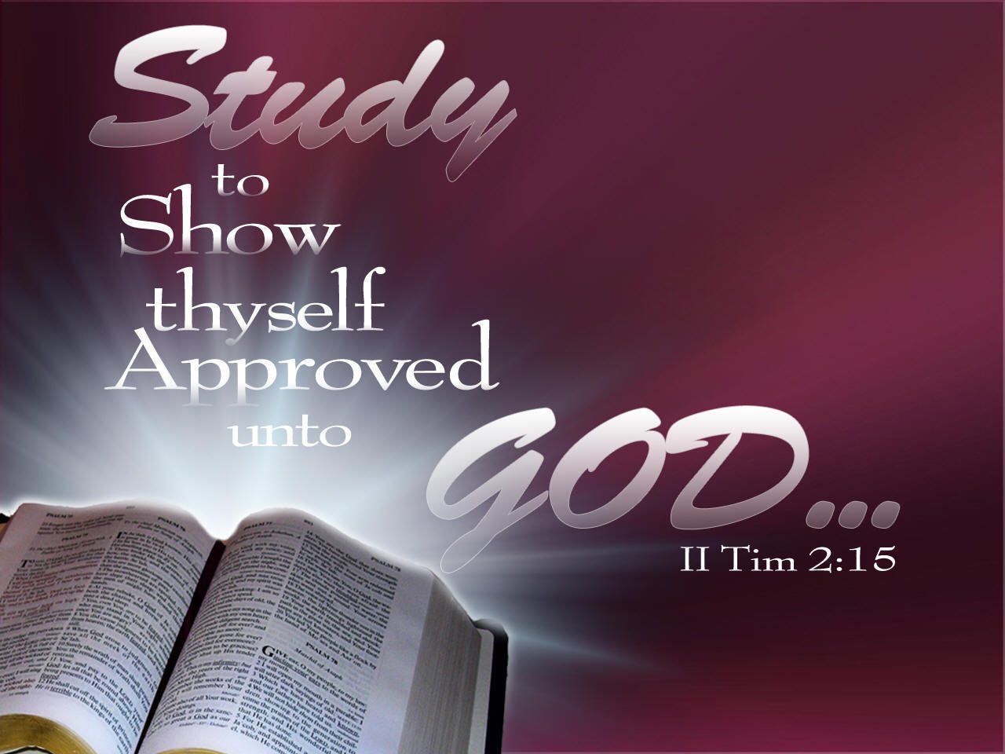

**HOPEWELL MB CHURCH**

**VIRTUAL INTERNATIONAL SUNDAY SCHOOL LESSON**

**OVERVIEW STUDY GUIDE**

The following information is provided for participants who wish to study the lesson beforehand. The study materials are part of the **International Sunday School Lesson**, excerpted from the **Union Gospel Press Sunday School book.**

The overview will be presented each Sunday Morning @ 9:15, prior to regular Sunday Morning Worship Service. Lesson discussion material will be rotated weekly amongst the various Target Groups (Adult Women, Adult Men, Young Adult, Youth) in an effort to include all ages in this lesson series.

The Overview is merely a brief discussion of the bible lesson. In order to gain a better understanding of the lesson, it is recommended that, prior to each lesson, participants read through the **Lesson Text**, **Related Scriptures**, **Daily Bible Reading** scriptures (each day), try to answer the **Discussion Questions**, and make a note of any additional questions you may have. Prayer and meditation are always essential in gaining a better understanding of God’s Word and its relevance to your life and situation.

Lessons may be viewed via facebook and youtube.

**March 2022**

**UNIT I: Instructions To A Troubled Church**

**All lessons this month will focus on selected passages from I Corinthians written by the Apostle Paul to the church at Corinth**

**WEEK 1- Divisions in Corinth:** Paul rebukes the church for allowing itself to be divided over leadership

**WEEK 2- True Wisdom:** Paul emphasizes that the message of the cross of Jesus Christ is the central

component of the ministry of the church and the hope of the believer

**WEEK 3- Christ-Our Only Foundation:** Paul reminds the people that all work in the church is built upon

the foundation of Jesus Christ

**WEEK 4- Members of Christ:** Paul warns of the dangers of sexual immorality and shows that the church is

the temple of the Holy Spirit

**HOPEWELL MB CHURCH**

**VIRTUAL SUNDAY SCHOOL LESSON OVERVIEW**

The following information is provided for participants who wish to study the lesson beforehand. The study materials are part of the **International Sunday School Lesson**, excerpted from the **Union Gospel Press Sunday School book.**

The overview will be presented each Sunday Morning @ 9:15, prior to regular Sunday Morning Worship Service.

**DATE OF LESSON:** March 6, 2022

**LESSON TITLE:** Divisions in Corinth

**LESSON TEXT:** I Corinthians 1:1-16

**RELATED SCRIPTURES:** I Corinthians 10:31-33; I Corinthians 12:1-31

**GOLDEN TEXT:** *“Now I Beseech you, brethren, by the name of our Lord Jesus Christ, that ye speak the same thing, and that there be no divisions among you; but that ye be perfectly joined together in the same mind and in the same judgement”* (I Corinthians 1:10)

**TARGET AGE GROUP:** This week’s discussion is taken from the **Adult Bible Class** book.

**DISCUSSION QUESTIONS**

1. **What does Paul assert at the outset of this letter?**
2. **What was so important about Paul’s claim to apostleship?**
3. **What does it mean to be sanctified?**
4. **What is a saint?**
5. **Why must we rely on God to sustain us and make us blameless instead of trying to sustain ourselves?**
6. **What was the major issue in Corinth that Paul dealt with first in this letter?**
7. **How is the church different from a social club or community group?**
8. **What does Paul’s choice to call the Corinthians “brothers” in verse 11 show us about disagreements in the church?**
9. **What was the cause of division in the Corinthian church?**
10. **Why was Paul glad that he had not baptized many in Corinth?**

**DAILY BIBLE READINGS**

**(Readings are for the week prior to the lesson)**

**M- Brothers Living in Unity (Psalms 133:1-3)**

**T- Neither Jew nor Greek (Galatians 3:26-29)**

**W- God’s Chosen People (Colossians 3:12-17)**

**Th- One Spirit (I Corinthians 12:1-11)**

**F- One Body (I Corinthians 12:12-31)**

**Sa- All for God’s Glory (I Corinthians 10:31-33)**

**Su- Is Christ Divided (I Corinthians 1:1-16)**

**HOPEWELL MB CHURCH**

**VIRTUAL SUNDAY SCHOOL LESSON OVERVIEW**

The following information is provided for participants who wish to study the lesson beforehand. The study materials are part of the **International Sunday School Lesson**, excerpted from the **Union Gospel Press Sunday School book.**

The overview will be presented each Sunday Morning @ 9:15, prior to regular Sunday Morning Worship Service.

**DATE OF LESSON:** March 13, 2022

**LESSON TITLE:** True Wisdom

**LESSON TEXT:** I Corinthians 1:17-31

**RELATED SCRIPTURES:** I Corinthians 2:1-16; Jeremiah 9:23-24; Romans 1:18-32; 11:33-36

**GOLDEN TEXT:** *“But God hath chosen the foolish things of the world to confound the wise; and God hath chosen the weak things of the world to confound the things which are mighty ”* (I Corinthians 1:27)

**TARGET AGE GROUP:** This week’s discussion is taken from the **Young** **Adult Bible Class** book.

**DISCUSSION QUESTIONS**

1. **What is the danger of relying on tactics other than the gospel to convert a person to the faith?**
2. **How does true wisdom begin?**
3. **What happened to many of God’s prophets and apostles? Why?**
4. **What did Paul mean by the foolishness of God? Is God ever really foolish?**
5. **Why does God so often choose the weak and lowly for His purposes?**
6. **How is Jesus Christ our wisdom?**
7. **How is Jesus Christ our righteousness?**
8. **How is Jesus Christ our sanctification?**
9. **How is Jesus Christ our redemption?**
10. **What is the difference between the truly wise and the truly foolish in this world?**

**DAILY BIBLE READINGS**

**(Readings are for the week prior to the lesson)**

**M- Worthy to Receive Wisdom (Revelations 5:9-14)**

**T- Drink Wisdom Freely (John 7:37-39)**

**W- Foolish Hearts Darkened (Romans 1:18-32)**

**Th- To God Be Glory (Romans 11:33-36)**

**F- Boast in the Lord (Jeremiah 9:23-24)**

**Sa- The Spirit’s Power (I Corinthians 2:1-16)**

**Su- We Proclaim Christ Crucified (I Corinthians 1:17-31)**

**HOPEWELL MB CHURCH**

**VIRTUAL SUNDAY SCHOOL LESSON OVERVIEW**

The following information is provided for participants who wish to study the lesson beforehand. The study materials are part of the **International Sunday School Lesson**, excerpted from the **Union Gospel Press Sunday School book.**

The overview will be presented each Sunday Morning @ 9:15, prior to regular Sunday Morning Worship Service.

**DATE OF LESSON:** March 20, 2022

**LESSON TITLE:** Christ-Our Only Foundation

**LESSON TEXT:** I Corinthians 3:10-23

**RELATED SCRIPTURES:** I Corinthians 3:1-9; Ephesians 2:19-22

**GOLDEN TEXT:** *“For other foundation can no man lay than that is laid, which is Jesus Christ”*

(I Corinthians 3:11)

**TARGET AGE GROUP:** This week’s discussion is taken from the **Youth Bible Class** book.

**DISCUSSION QUESTIONS**

1. **Who do some liberal theologians believe founded Christianity?**
2. **Who actually is the foundation of the church?**
3. **What is another name for the final day?**
4. **What will happen to faulty builders?**
5. **What type of minister is in danger of eternal condemnation by the Lord?**
6. **Who did Paul warn against self-deception?**
7. **What was Paul’s advice to those who considered themselves to be wise by the world’s standards?**
8. **What original message of Jesus is the basis of Paul’s teachings about wisdom and truth?**

**DAILY BIBLE READINGS**

**(Readings are for the week prior to the lesson)**

**M- Be Like-Minded (Philippians 2:1-4)**

**T- Build Up Fellow Believers (Romans 15:1-13)**

**W- Members Together (Ephesians 3:1-13)**

**Th- A Chosen People (I Peter 2:1-10)**

**F- Christ the Chief Cornerstone (Ephesians 2:19-22)**

**Sa- God Gives the Growth (I Corinthians 3:1-9)**

**Su- Building Carefully on the Foundation (I Corinthians 3:10-23)**

**HOPEWELL MB CHURCH**

**VIRTUAL SUNDAY SCHOOL LESSON OVERVIEW**

The following information is provided for participants who wish to study the lesson beforehand. The study materials are part of the **International Sunday School Lesson**, excerpted from the **Union Gospel Press Sunday School book.**

The overview will be presented each Sunday Morning @ 9:15, prior to regular Sunday Morning Worship Service.

**DATE OF LESSON:** March 27, 2022

**LESSON TITLE:** Members of Christ

**LESSON TEXT:** I Corinthians 6:12-20

**RELATED SCRIPTURES:** I Corinthians 5:1-13; 6:1-11; I Thessalonians 4:3-8; Colossians 3:1-11;

Romans 6:1-14

**GOLDEN TEXT:** *“What? Know ye not that your body is the temple of the Holy Ghost which is in you, which ye have of God, and ye are not your own? For ye are bought with a price: therefore glorify God in your body, and in your spirit, which are God’s ”*  (I Corinthians 6:19-20)

**TARGET AGE GROUP:** This week’s discussion is taken from the **Adult Bible Class** book.

**DISCUSSION QUESTIONS**

1. **How did Paul respond to the claim that “all things are lawful”?**
2. **What was meant by the expression, “Meats for the belly, and the belly for meats”?**
3. **How did Paul respond to this claim?**
4. **What did Paul mean when he said that we are members of Christ?**
5. **Why did Paul ask the Corinthians, “Know ye not”?**
6. **What picture did Paul use to demonstrate how reprehensible sexual sin was?**
7. **What was meant by “they shall be one flesh” (Genesis 2:24)?**
8. **How did Paul say we are to deal with sexual temptation?**
9. **Why is sexual sin so much more damaging than other sins?**
10. **Why can we not say that our bodies belong to ourselves?**

**DAILY BIBLE READINGS**

**(Readings are for the week prior to the lesson)**

**M- Counted Dead to Sin (Romans 6:1-14)**

**T- Hidden in Christ (Colossians 3:1-11)**

**W- Called to Holiness (I Thessalonians 4:3-8)**

**Th- Disunity Among Believers (I Corinthians 6:1-11)**

**F- Expel the Wicked Person (I Corinthians 5:1-6)**

**Sa- Marital Obligations (I Corinthians 7:1-7)**

**Su- Glorify God in Your Body (I Corinthians 6:12-20)**