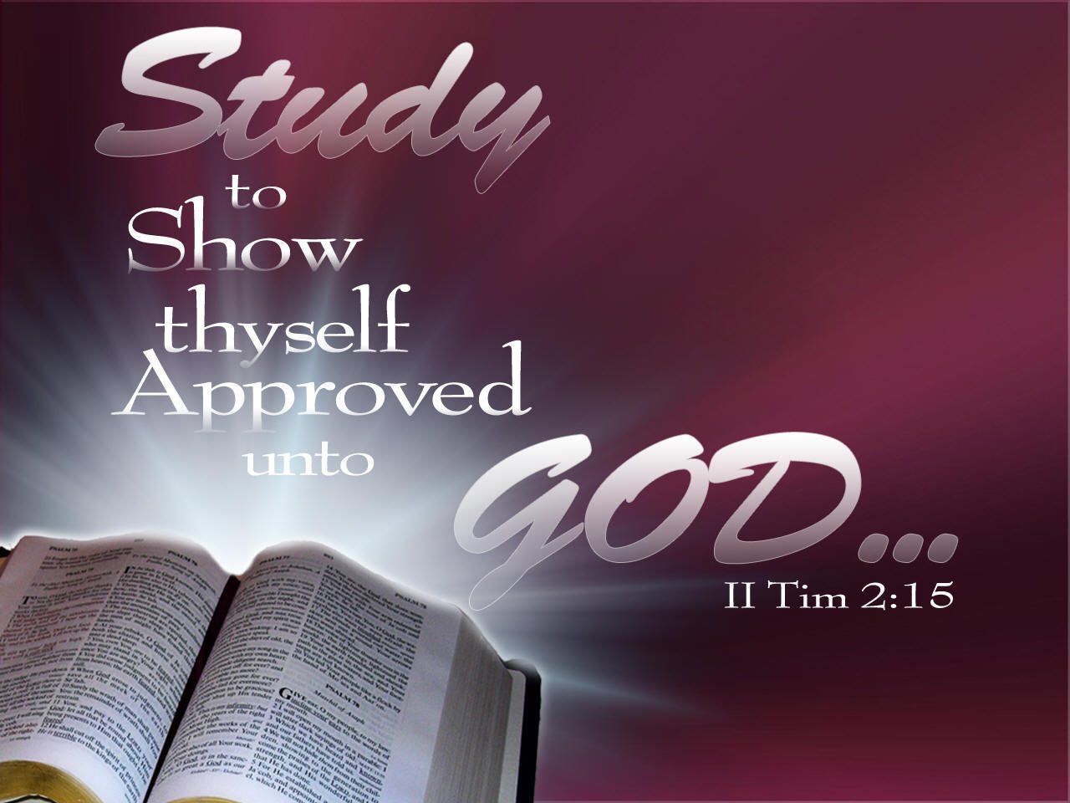

**HOPEWELL MB CHURCH**

**VIRTUAL INTERNATIONAL SUNDAY SCHOOL LESSON**

**OVERVIEW STUDY GUIDE**

The following information is provided for participants who wish to study the lesson beforehand. The study materials are part of the **International Sunday School Lesson**, excerpted from the **Union Gospel Press Sunday School book.**

The overview will be presented each Sunday Morning @ 9:15, prior to regular Sunday Morning Worship Service. Lesson discussion material will be rotated weekly amongst the various Target Groups (Adult Women, Adult Men, Young Adult, Youth) in an effort to include all ages in this lesson series.

The Overview is merely a brief discussion of the bible lesson. In order to gain a better understanding of the lesson, it is recommended that, prior to each lesson, participants read through the **Lesson Text**, **Related Scriptures**, **Daily Bible Reading** scriptures (each day), try to answer the **Discussion Questions**, and make a note of any additional questions you may have. Prayer and meditation are always essential in gaining a better understanding of God’s Word and its relevance to your life and situation.

Lessons may be viewed via facebook and youtube.

**February 2022**

**UNIT III: Triumph Over Trials**

**All lessons this month will focus on Jesus’ Trials, Crucifixion and Death, and what took place following Jesus’ Resurrection.**

**WEEK 1- Trials and Denials:** Peter’s denial of Jesus and Jesus’ trial before Annas

**WEEK 2- Pilate: What Is Truth?:** Pilate’s approval was needed in order to declare Jesus guilty of

blasphemy

**WEEK 3- Crucifixion and Death:** Jesus was delivered to the Jewish leaders to be crucified

**WEEK 4- Jesus by the Sea of Tiberias:** After a night of unsuccessful fishing, the disciples spot Jesus on

the beach cooking fish

**HOPEWELL MB CHURCH**

**VIRTUAL SUNDAY SCHOOL LESSON OVERVIEW**

The following information is provided for participants who wish to study the lesson beforehand. The study materials are part of the **International Sunday School Lesson**, excerpted from the **Union Gospel Press Sunday School book.**

The overview will be presented each Sunday Morning @ 9:15, prior to regular Sunday Morning Worship Service.

**DATE OF LESSON:** February 6, 2022

**LESSON TITLE:** Trials and Denials

**LESSON TEXT:** John 18:15-27

**RELATED SCRIPTURES:** Matthew 26:59-75; Mark 14:55-72; Luke 22:55-71

**GOLDEN TEXT:** *“Jesus said, I am: and ye shall see the Son of man sitting on the right hand of*

*power, and coming in the clouds of heaven”* (Mark 14:62)

**TARGET AGE GROUP:** This week’s discussion is taken from the **Adult Bible Class** book.

**DISCUSSION QUESTIONS**

1. **Which disciples followed Jesus after His arrest?**
2. **How did those disciples gain entrance to the high priest’s house?**
3. **Who first challenged Peter about whether he was Jesus’ disciple?**
4. **What did Peter do that set him up for his subsequent denials of Jesus?**
5. **Who first questioned Jesus after His arrest?**
6. **What two things was Jesus questioned about?**
7. **How did Jesus respond to the question about His teachings?**
8. **Why did the officer slap Jesus across the face?**
9. **Where was Jesus sent next?**
10. **Who challenged Peter about Jesus the third time?**

**DAILY BIBLE READINGS**

**(Readings are for the week prior to the lesson)**

**M- The Messiah Oppressed (Isaiah 53:7-9)**

**T- Peter Weeps (Luke 22:55-62)**

**W- The Soldiers Mock (Luke 22:63-71)**

**Th- The Son of Man (Mark 14:55-72)**

**F- Jesus Before the Sanhedrin (Matthew 26:57-68)**

**Sa- Peter’s Denial (Matthew 26:69-75)**

**Su- The Rooster Crows (John 18:15-27)**

**HOPEWELL MB CHURCH**

**VIRTUAL SUNDAY SCHOOL LESSON OVERVIEW**

The following information is provided for participants who wish to study the lesson beforehand. The study materials are part of the **International Sunday School Lesson**, excerpted from the **Union Gospel Press Sunday School book.**

The overview will be presented each Sunday Morning @ 9:15, prior to regular Sunday Morning Worship Service.

**DATE OF LESSON:** February 13, 2022

**LESSON TITLE:** Pilate: What Is Truth?

**LESSON TEXT:** John 18:28-40

**RELATED SCRIPTURES:** Isaiah 53:1-9; Matthew 27:11-18, 20-24; Mark 15:1-15; Luke 18:32-33; 23:1-25

**GOLDEN TEXT:** *“Jesus answered, My kingdom is not of this world: if my kingdom were of this world, then would my servants fight, that I should not be delivered to the Jews: but now is my kingdom not from hence” ”* (John 18:36)

**TARGET AGE GROUP:** This week’s discussion is taken from the **Young** **Adult Bible Class** book.

**DISCUSSION QUESTIONS**

1. **What was the “hall of judgement” (John 18:28)?**
2. **Why did the Jews refuse to enter the hall of judgement?**
3. **Why did the Jewish authorities need to take Jesus to Pilate?**
4. **What is a “malefactor” (v. 30)?**
5. **For what other reason was it important that Jesus be turned over to the Romans?**
6. **What was Pilate’s initial response to the Jewish leaders’ demand?**
7. **What accusation against Jesus did the Jewish leaders bring that caught Pilate’s attention?**
8. **What did Jesus mean by saying that His kingdom “is not of this world” (v. 36)?**
9. **What did Pilate mean by his response, “What is truth” (v. 38)?**
10. **Who was Barabbas?**

**DAILY BIBLE READINGS**

**(Readings are for the week prior to the lesson)**

**M- Jesus Predicts His Death (Luke 18:31-33)**

**T- Jesus the King (Luke 23:1-12)**

**W- Barabbas Released (Luke 23:13-25)**

**Th- Pilate Amazed (Mark 15:1-15)**

**F- No Reply (Matthew 27:11-18)**

**Sa- The Cry of the Crowd (Matthew 27:20-26)**

**Su- Jesus Before Pilate (John 18:28-40)**

**HOPEWELL MB CHURCH**

**VIRTUAL SUNDAY SCHOOL LESSON OVERVIEW**

The following information is provided for participants who wish to study the lesson beforehand. The study materials are part of the **International Sunday School Lesson**, excerpted from the **Union Gospel Press Sunday School book.**

The overview will be presented each Sunday Morning @ 9:15, prior to regular Sunday Morning Worship Service.

**DATE OF LESSON:** February 20, 2022

**LESSON TITLE:** Crucifixion and Death

**LESSON TEXT:** John 19:16-30

**RELATED SCRIPTURES:** Psalm 22:12-18; Matthew 27:27-56; Mark 15:16-32; Luke 23:26-43

**GOLDEN TEXT:** *“When Jesus therefore had received the vinegar, he said, It is finished: and he*

*bowed his head, and gave up the ghost”* (John 19:30)

**TARGET AGE GROUP:** This week’s discussion is taken from the **Youth Bible Class** book.

**DISCUSSION QUESTIONS**

1. **Why was the placard that Pilate placed on Jesus’ cross an insult toward the Jewish nation?**
2. **How was the charge on Jesus’ placard also a proclamation of the glory of Christ?**
3. **How did the actions of the soldiers at the cross fulfill Old Testament prophecy?**
4. **How was the love of Christ demonstrated through His provision for His mother’s care?**
5. **What was God accomplishing through Jesus’ death on the cross?**
6. **What was the significance of Jesus’ thirst?**
7. **How was Jesus’ final cry one of victory rather than defeat?**

**DAILY BIBLE READINGS**

**(Readings are for the week prior to the lesson)**

**M- His Bones Out of Joint (Psalms 22:12-18)**

**T- Jesus Led Away (Luke 23:26-43)**

**W- Jesus Breathes His Last (Luke 23:44-49)**

**Th- The King of the Jews (Mark 15:16-32)**

**F- Simon Carries the Cross (Matthew 27:27-44)**

**Sa- Darkness Over the Land (Matthew 27:45-56)**

**Su- It Is Finished (John 19:16-30)**

**HOPEWELL MB CHURCH**

**VIRTUAL SUNDAY SCHOOL LESSON OVERVIEW**

The following information is provided for participants who wish to study the lesson beforehand. The study materials are part of the **International Sunday School Lesson**, excerpted from the **Union Gospel Press Sunday School book.**

The overview will be presented each Sunday Morning @ 9:15, prior to regular Sunday Morning Worship Service.

**DATE OF LESSON:** February 27, 2022

**LESSON TITLE:** Jesus By the Sea of Tiberias

**LESSON TEXT:** John 21:1-14

**RELATED SCRIPTURES:** Luke 5:1-11; John 20:19-29; 21:15-25

**GOLDEN TEXT:** *“This is now the third time that Jesus shewed himself to his disciples, after that*

*he was risen from the dead ”*  (John 21:14)

**TARGET AGE GROUP:** This week’s discussion is taken from the **Adult Bible Class** book.

**DISCUSSION QUESTIONS**

1. **What is another name for the Sea of Tiberias?**
2. **How many disciples are mentioned in this post-resurrection appearance?**
3. **Why did Peter decide to go fishing?**
4. **How did the disciples’ fishing expedition turn out?**
5. **Why might Jesus not have been immediately recognized by the disciples?**
6. **What did the Lord tell His disciples to do?**
7. **What did Peter do once he realized that it was Jesus on the shore?**
8. **What had the Lord prepared for His disciples?**
9. **How many fish did the disciples catch?**
10. **What might John have meant in saying that this was the third time Jesus appeared after His resurrection?**

**DAILY BIBLE READINGS**

**(Readings are for the week prior to the lesson)**

**M- Jesus Calls His First Disciples (Luke 5:1-11)**

**T- Fishers of Men (Mark 1:16-20)**

**W- Shepherds and Sheep (Ezekiel 34:11-16)**

**Th- The Good Shepherd (John 10:11-18)**

**F- Jesus Appears to His Disciples (John 20:19-29)**

**Sa- Jesus Reinstates Peter (John 17:20-26John 21:15-25)**

**Su- A Great Catch of Fish (John 21:1-14)**